**Product**: SARS-CoV-2 N protein ELISA Kit

**Catalog NO.**: NE-xg-E001

**Assay Type**: **Sandwich**

**Research Area**: Infection immunity

#### Synonyms: SARS-CoV-2 Nucleoprotein; SARS-CoV-2 NP; SARS-CoV-2 Nucleocapsid protein; SARS-Cov-2 NC; SARS-Cov-2 Protein N; COVID-19 Nucleoprotein; NCP; 2019-nCoV

**Detection Range**:125 -8,000 pg/mL

**Sensitivity**: 38.74 pg/mL

**Standard Preparation**

Reconstitute the **Standard** with 1.0 mL of**Universal Diluent**, keep for 10 minutes at room temperature, shake gently(not to foam). The concentration of the standard in the stock solution is 8,000 pg/mL. Please prepare 7 tubes containing 0.5 mL **Universal Diluent** and produce a double dilution series according to the picture shown below. Mix each tube thoroughly before the next transfer. Set up 7 points of diluted standard such as 8,000 pg/mL, 4,000 pg/mL, 2,000 pg/mL, 1,000 pg/mL, 500 pg/mL, 250 pg/mL, 125 pg/mL, and the last EP tube with **Universal Diluent**  is the blank as 0 pg/mL.

500ul 500ul 500ul 500ul 500ul

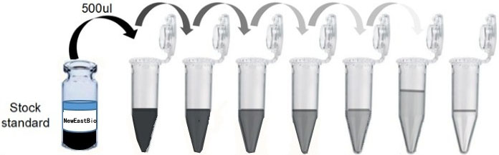

pg/mL 8,000 4,000 2,000 1,000 500 250 125 0

**Typical Data**

As the OD values of the standard curve may vary according to the conditions of the objective assay, the experimenter should fit a standard curve for each test. Typical standard curve provided below is for reference only.



**Specificity**

This assay has high sensitivity and excellent specificity for detection of SARS-CoV-2 N protein. No significant cross-reactivity or interference between SARS-CoV-2 N protein and analogues is observed.

**Note**: Limited by current skills and knowledge, it is impossible for us to complete the cross-reactivity detection between SARS-CoV-2 N protein and all the analogues, therefore, cross reaction may still exist.

**Recovery**

Matrices listed below were spiked with certain level of recombinant SARS-CoV-2 N protein and the recovery rates were calculated by comparing the measured value to the expected amount of SARS-CoV-2 N protein in samples.

|  |  |  |
| --- | --- | --- |
| **Matrix** | **Recovery range(%)** | **Average(%)** |
| Serum(n=10) | 83-107 | 95 |
| EDTA plasma(n=10) | 82-94 | 85 |
| Heparin plasma(n=10) | 83-99 | 91 |

**Linearity**

The linearity of the kit was assayed by testing samples spiked with appropriate concentration of SARS-CoV-2 N protein and their serial dilutions. The results were demonstrated by the percentage of calculated concentration to the expected.

|  |  |  |  |  |
| --- | --- | --- | --- | --- |
| **Sample** | **1:2** | **1:4** | **1:8** | **1:16** |
| Serum(n=10) | 83-95% | 89-103% | 82-99% | 79-107% |
| EDTA plasma(n=10) | 92-104% | 91-99% | 78-98% | 80-94% |
| Heparin plasma(n=10) | 86-105% | 89-102% | 81-97% | 85-92% |

**Precision**

Intra-assay Precision (Precision within an assay): Three samples with low, middle and high level SARS-CoV-2 N protein were tested 20 times on one plate, respectively.

Inter-assay Precision (Precision between assays): Three samples with low, middle and high level SARS-CoV-2 N protein were tested on 3 different plates, 8 replicates in each plate.

**CV (%)** = SD/meanX100

**Intra-Assay**: CV< 10%

**Inter-Assay**: CV< 12%

**Stability**

The stability of ELISA kit is determined by the loss rate of activity. The loss rate of this kit is less than 10% within the expiration date under appropriate storage condition.

|  |  |  |
| --- | --- | --- |
| **Main components** | **37℃ for 7 days** | **-20℃ for 12 months** |
| Average(%) | 90 | 95-100 |

To minimize extra influence on the performance, operation procedures and lab conditions,

especially room temperature, air humidity, incubator temperature should be strictly controlled. It is strongly suggested that the same operator performs the whole assay from the beginning to the end.